Gap Analysis:
Establishing therapeutic Relationships July 2002 revised 2006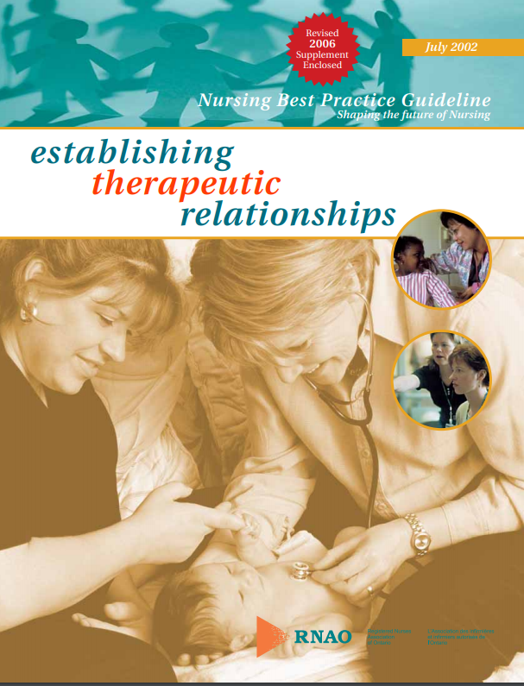
Work Sheet

This guideline can be downloaded for free at:
https://rnao.ca/sites/rnao-ca/files/Establishing_Therapeutic_Relationships.pdf
The RNAO Leading Change Toolkit 3rd Edition
https://rnao.ca/leading-change-toolkit

Date Completed:
Team Members participating in the Gap Analysis:
Completion of this gap analysis allows for the annual comparison of your current practice to evidence-based practices as regulated by the MOHLTC per Fixing Long-Term Care Act, 2021 at https://www.ontario.ca/laws/statute/21f39 & O. Reg. 246/22: GENERAL (ontario.ca)
RNAO Healthy Work Environment Best Practice Guideline Recommendations | Met | Partially Met | Unmet | Notes  (Examples of what to include: is this a priority to our home, information on current practice, possible overlap with other programs or partners)
Recommendations
1.The nurse must acquire the necessary knowledge to participate effectively in therapeutic relationships.
2.Establishment of a therapeutic relationship requires reflective practice. This concept includes the required capacities of: selfawareness, self-knowledge, empathy, awareness of boundaries and limits of the professional role.
3.The nurse needs to understand the process of a therapeutic relationship and be able to recognize the current phase of his/her relationship with the client.
4.All entry-level nursing programs must include in-depth learning about the therapeutic process, including both theoretical content and supervised practice.
5.Organizations will consider the therapeutic relationship as the basis of nursing practice and, over time, will integrate a variety of professional development opportunities to support nurses in effectively developing these relationships. Opportunities must include nursing consultation, clinical supervision and coaching
6.Health care agencies will implement a model of care that promotes consistency of the nurse-client assignment, such as primary nursing.
7.Agencies will ensure that at minimum, 70 per cent of their nurses are working on a permanent, full-time basis.
8.Agencies will ensure that nurses’ workload is maintained at levels conducive to developing therapeutic relationships.
9.Staffing decisions must consider client acuity, complexity level, complexity of work environment, and the availability of expert resources.
10.Organizations will consider the nurse’s well-being as vital to the development of therapeutic nurse-client relationships and support the nurse as necessary.
11.Organizations will assist in advancing knowledge about therapeutic relationships by disseminating nursing research, supporting the nurse in using these findings, and supporting his/her participation in the research process
12.Agencies will have a highly visible nursing leadership that establishes and maintains mechanisms to promote open conversation between nurses and all levels of management, including senior management
13.Resources must be allocated to support clinical supervision and coaching processes to ensure that all nurses have clinical supervision and coaching on a regular basis.
14.Organizations are encouraged to include the development of nursing best practice guidelines in their annual review of performance indicators/quality improvement, and accreditation bodies are also encouraged to incorporate nursing best practice guidelines into their standards

